Microservices architecture is a way of building an application where a big system is divided into smaller, independent services. Each service handles a specific task, works on its own, and communicates with other services using APIs. This makes the application more flexible, easier to update, and better for scaling.
🔹 Key Points
- Each service does one specific job
- Services are independent (no strong dependency)
- Communication happens through APIs (HTTP)
- Each service can use its own database (like MongoDB)
- Different services can use different technologies
- Easy to scale only required parts
👉 In short: Microservices = small independent services working together to form one big application
✅ Service Discovery (Simple Explanation)
Service discovery is a mechanism that helps microservices find and communicate with each other automatically without hardcoding their locations (IP address or URL).

🔹 Why it is needed
In microservices:
- Services are created/destroyed dynamically
- Their locations (IP/port) keep changing
👉 So, instead of hardcoding addresses, service discovery helps services locate each other easily

🔹 How it works (simple)
- Each service registers itself in a service registry
- Other services ask the registry:
👉 “Where is this service?”
- Registry provides the current address
- Services communicate

🔹 Example
- Order Service needs User Service
- It asks Service Discovery
- Gets User Service address
- Sends request

🔹 Common Tools
- Eureka
- Consul
- Zookeeper

👉 In short:
Service discovery = a system that helps microservices find each other automatically

✅ API Gateway (Simple Explanation)
API Gateway is a single entry point through which all client requests go before reaching the microservices.

🔹 What it does
- Receives all requests from client (frontend)
- Sends request to the correct microservice
- Returns the response back to client

🔹 Why it is used
- Client doesn’t need to call many services directly
- Simplifies communication
- Handles common tasks like:
  - Authentication
  - Logging
  - Load balancing

🔹 Example
- User sends request → API Gateway
- Gateway → sends to Order Service
- Order Service → sends response
- Gateway → returns response to user

🔹 In Short
👉 API Gateway = main entry point that routes requests to the correct microservice

✅ Configuration Server (Simple Explanation)
Configuration Server is a central place where all microservices store and get their configuration settings (like database URL, API keys, etc.).

🔹 What it does
- Stores configuration for all services in one place
- Services fetch their config from this server
- Makes it easy to change settings without changing code

🔹 Why it is used
- Avoids hardcoding values in each service
- Easy to manage configs for many services
- If config changes → no need to update every service manually

🔹 Example
- User Service needs database URL
- It gets it from Configuration Server
- If DB changes → update only in server

🔹 In Short
👉 Configuration Server = central place to manage settings for all microservices

✅ Circuit Breaker (Simple Explanation)
Circuit Breaker is a design pattern used in microservices to prevent system failure when one service is down or slow.

🔹 What it does
- Stops repeated calls to a failing service
- Protects the system from crashing

🔹 How it works (simple)
It has 3 states:
- Closed
  - Normal state
  - Requests go to service
- Open
  - Service is failing
  - Requests are blocked (no calls made)
- Half-Open
  - Tries a few requests
  - If success → back to normal
  - If fail → stays open

🔹 Example
- Payment Service is down
- Order Service tries to call → fails many times
- Circuit breaker stops further calls
- Prevents system overload

🔹 Why it is used
- Improves system stability
- Avoids cascading failures
- Faster response (fail fast)

🔹 In Short
👉 Circuit Breaker = a safety mechanism that stops calls to a failing service

Feign Client:
- Student1
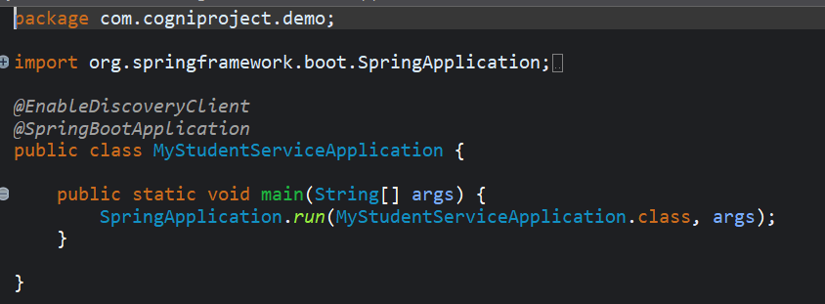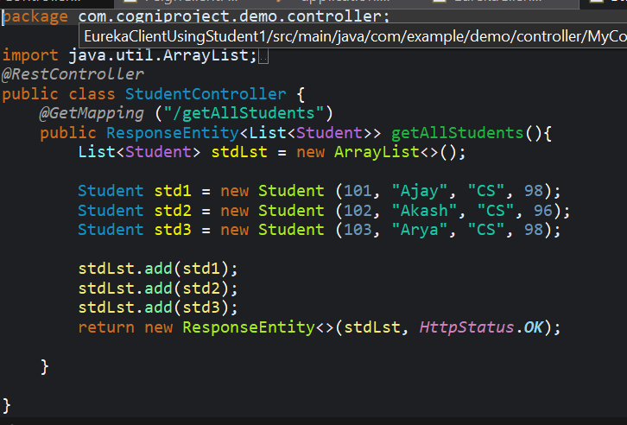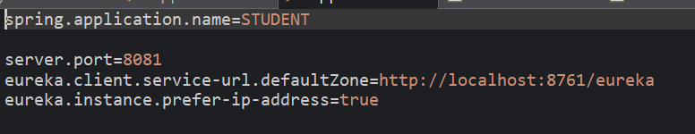

- Eureka Client
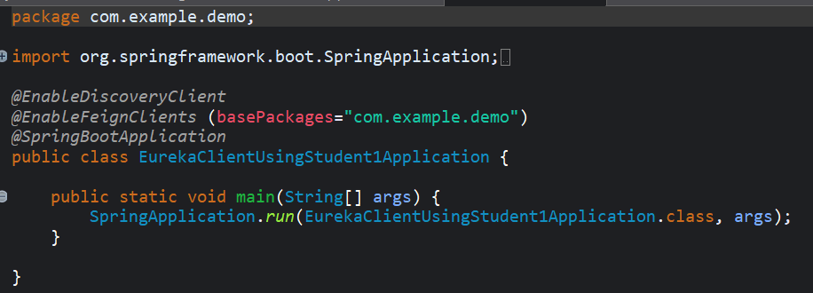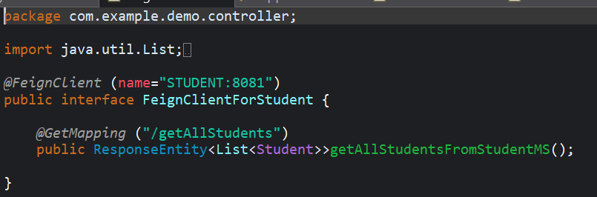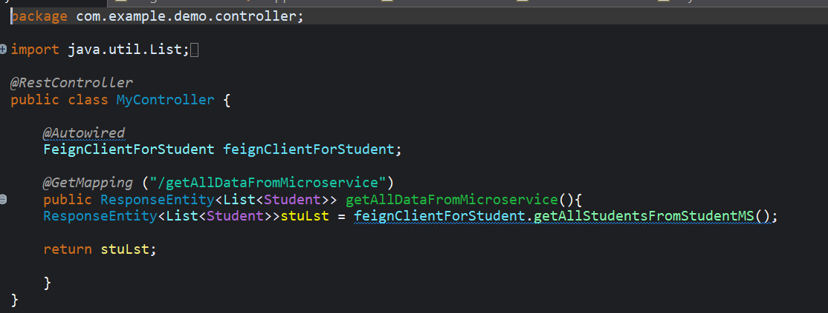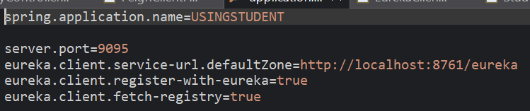
Eureka server:
